**Did all the Waldensians observe the Sabbath? A Note**

By Craig M White

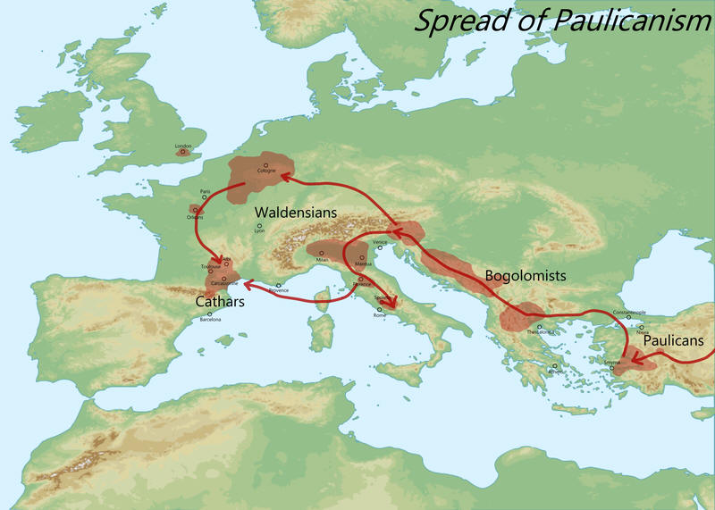

*Graphic source: Wikipedia*

**Articles by others on the Waldenses available**[**here**](https://www.friendsofsabbath.org/Further_Research/History%20of%20the%20Sabbatarian%20Movement/Waldensians)(NB: not all of this information is about those that were called Waldenses who observed the Sabbaths. Most who were known as Waldenses did not observe the seventh-day Sabbath).

It must have been in 1977 or 1978 that I discovered Gerard Damsteegt, a SDA scholar who authored a fascinating book ‘Foundations of the Seventh-day Adventist Message and Mission’ in the SDA bookshop in Perth.

The SDA bookshop also had a lot of old pre-SDA literature and original SDA literature. Years before, as a youngster, I read their literature in the Port Elizabeth, South Africa library as part of my research. Uriah Smith in particular interested me. The other SDA bookshops in Strathfield (a suburb of Sydney) and Avondale College also contained much old literature. Nowadays, that has changed and their bookshops are more and more mainstream and without depth.

 I found the book by Damsteegt intriguing filled with all sorts of fascinating titbits – include a copy of the SDA 1872 Fundamentals. This included article V:

 >V. That the new birth comprises the entire change necessary to fit us for the kingdom of God, and consists of two parts: first, a moral change, wrought by conversion and a Christian life; second, a physical change at the second coming of Christ, whereby, if dead, we are raised incorruptible, and if living, are changed to immortality in a moment, in the twinkling of an eye. John 3:3, 5; Luke 20:36.<

 Some time later (2005), I obtained an article by him arguing for the Waldenses (or many of them) being Sabbath-keepers. The article was titled The Waldenses. An Analysis of Insabbatati.

 In June 2010 he advised me he was withdrawing the article, pending the publication of further research, after rigorous review. His new article was published in 2016 and is available [here](https://www.friendsofsabbath.org/Further_Research/History%20of%20the%20Sabbatarian%20Movement/Waldensians) (Decoding Ancient Waldensian Names: New Discoveries). Shows you how long it can take for scholarly articles to be reviewed and accepted for publication and to finally be published behind a queue of others!

 I think you will find the article of great interest – in particular the 16th page onward following the sub-heading Waldensian Sabbath-keepers. I think it shows that the Waldensians, much like the terms Adventist or Scythian, is an umbrella term for several groups.

 Finally, let me make this point: I have much literature on the Waldensians and from what I could gather, there were Sabbatarians amongst them. It was rather obvious from my readings that many Waldensians observed the 7th day Sabbath, but most didn't. We should not force history into our template, but deeply and honestly study the records.

 The old WCG papers by Lester Grabbe "Were the Waldenses a part of God's Church?" (1981) and Lawson Briggs “Did Peter Waldo Keep the Sabbath?” (1974) notwithstanding, some Waldenses did indeed observe the seventh day Sabbath.